**Stage 5: Final Report**

**Group:** **Abdul Aaquib (800795370) 4/29/2013**

**Nikhil Dahake (800804352)**

**Pritesh Bhere (800776144)**

**Stage 1 :**

This stage was about forming group a group for the project and deciding the domain we would like to do our project on. We formed a 3 member group and decided to do a project on the movies domain.

**Stage 2:**

This stage consisted of designing an ER diagram for the project, the use cases, deciding the functionalities to offer and implementing a cool feature for the project.

We successfully constructed an ER diagram for the project. This ER diagram was designed with great thought about how the various functionalities in the project would be accomplished.

The cool feature that we implemented was that of **auto complete**. In the movies domain, if the user types in the partial name of a movie in the search box, then all the matches for that particular string in the search box would be shown to the user.

Another thing that we did was providing a GUI for our project.

The ER diagram of our project is given below:

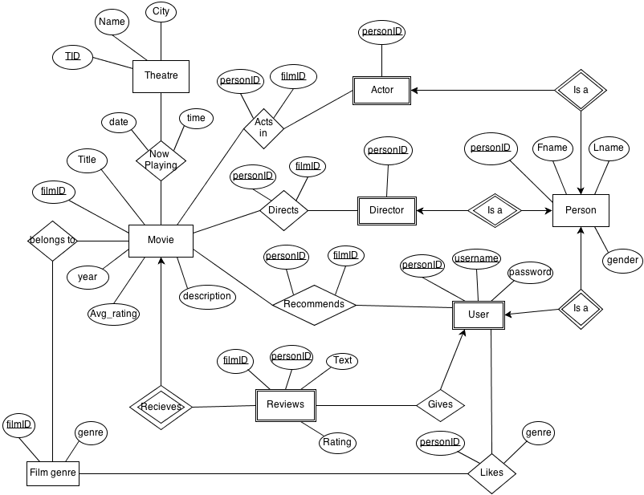

**Stage 3:**

This was one of the most toughest stages. It involved implementing the ER diagram designed in stage 2. Constructing the tables in my sql, deciding the primary keys, indexes and the division of labour.

**Stage 4:**

We constructed a mockup of our project and took some screenshots. This gave us an idea about how our final project would look like.

**Stage 5:**

● Briefly describe what the project accomplished.

We accomplished what we originally set out to do. We developed a database application for storing and displaying information related to movies. The database stores information such as:

* The title
* Year of release,
* Avg. rating
* Description of the movie.
* The actors,
* Directors,
* Theatre it is playing in along with the date and time.
* Genre of the movie
* Reviews and ratings given by the users of the application.
* Information about the users of the application such as their SSN, name, gender, username and password.
* Finally , the database also stores which genres each user likes and which movies they recommend.

We have implemented the following functionalities:

1. Users can search for a movie based on different aspects of the movie like movie name, directors and actors.
2. Users can find the theatre, date and time that a movie is playing at.
3. Users can give reviews for movies. They can also delete or update their reviews.
4. Users can rate movies.
5. Users can recommend movies to other users.
6. The application computes which movies a user is most likely to watch based on profiles of other users with similar tastes.
7. Users can login or register. The application provides a personalized user homepage and remembers the recommended movies to the user from the last time the user logged in.
8. The application has a text autocomplete feature when the users search for movies.

● State if everything went according to the plan and the designed specifications. If not, then why.

Almost everything went according to the plan and the designed specifications. We had planned to provide theatre search based on the city, movie, and the date and time the movie is playing at but couldn’t complete it because of time constraints. But we did manage to include the theatre information in the database and display the theaters, dates and times a movie is playing at.

One of the challenges we faced was to come up with a way to recommend movies to users intelligently based on profiles of other users with similar tastes. We came up with the following query which accomplished this objective perfectly.

SELECT DISTINCT title

FROM (SELECT filmID,title

FROM movie

WHERE title IN (SELECT DISTINCT m.title

FROM movie m,recommend r

WHERE m.filmID=r.filmID AND

r.SSN IN (SELECT l1.SSN

FROM Likes l1,Likes l2

Where l1.genre=l2.genre AND l2.SSN = " + ssn + " AND

l1.SSN < l2.SSN))) t, genre g

WHERE t.filmID=g.filmID AND

genre IN (Select genre

FROM Likes

WHERE SSN = "+ ssn +");

The above query first finds out the other users who like the same genre as the current user. Then it selects all the movies recommended by those users and finally filters those movies based on the genres selected by the user in the application.

● Describe the final division of labor (who did what),

Abdul Aaquib:

* Database design and implementation
* Data entry
* Designed a customized user home page with dynamic display of data
* Queries to recommend movies to the user based on the profile of other users with similar tastes
* Testing

Nikhil Dahake:

* Database Design
* Project management
* Designed the movie info page
* Display of theatre information along with dates and times
* Queries to enable users to rate movies and write reviews which can also be updated later
* Testing

Pritesh Bhere:

* Database Design
* Project integration
* Designed the welcome page, the login and register page
* Login/register functionality
* Queries to search for movies based on title, actors, and directors.

● Brief comments on the project: Do you like the way it is organized? What do you want to change?

* The project is well organized.
* We spent a lot of time on the database design and came up with a good and efficient relational schema.
* We worked on the UI independently. Each person was responsible for different pages and each one came up with different ideas to implement the functionalities in his page.
* Finally, all of us worked on integrating the different components to form the final application. We have done everything exactly the way we planned it and the project has turned out very good.
* The only functionality that was left out was the theatre search which allowed the users to search for theaters nearby based on movie, date and time due to time constraints. But we were able to store and display information about the theatres and show timings for each movie.
* Another change that we could have implemented would have been encrypting the passwords in the databases with AES. Doing so would have prevent anyone from looking at the password by looking them up in the database.
* The current data in the database has been manually fed. This could be improved upon. We could have fetched data from various RSS feeds on the internet eg. websites like imdb, rotten tomatoes and so on.
* We could have provided an administrator login which would have allowed the administrator to handle issues that user were facing and so on.
* The user interface could have been web based . Doing so would have allowed several users to access the project simultaneously. We could have done this using java servlets.

● Any other issue you would like to bring to our attention while grading your project.

The project works fine. The scope of the project was limited . However, all the functionality that was originally planned has been successfully implemented. There are no special concerns that we would like to bring to your notice.

There might be some bugs or a little bit of broken functionality. However, the main **CRUD** operations are working without a glitch.